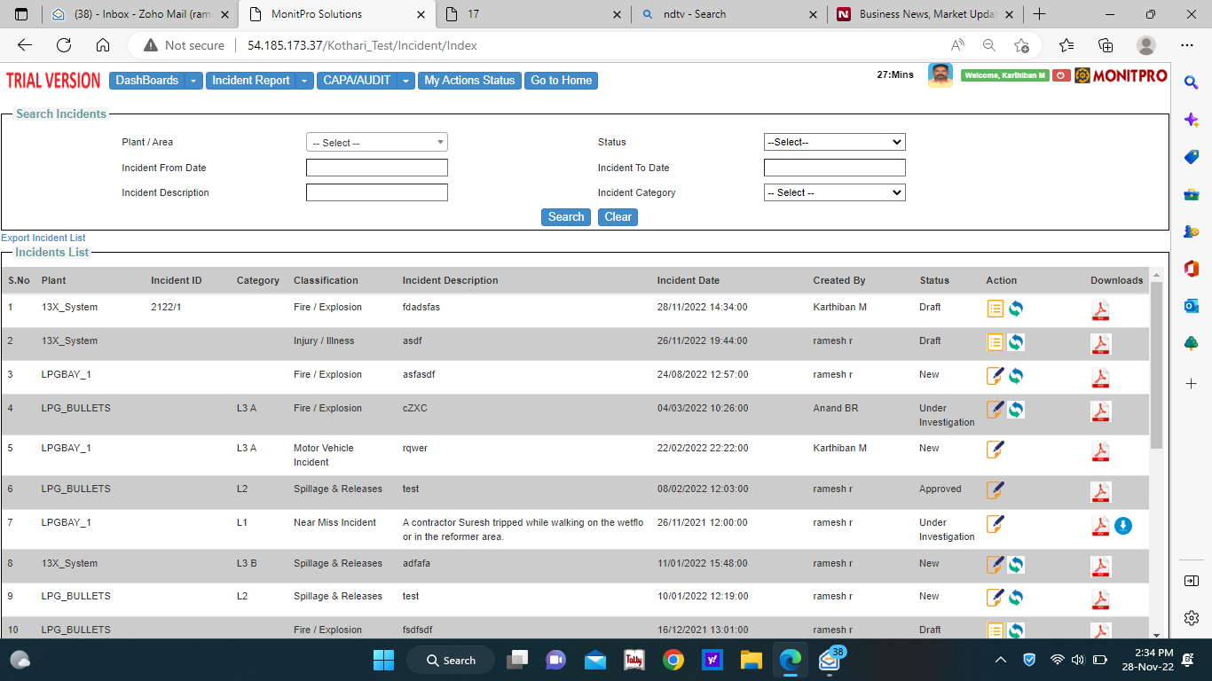

Add Filter: Incident Classification (swap as per table order)

Session time: Keep it 60 Min

ID:2223/ number (can’t start from 1, but reset only in April)

Rename: Home

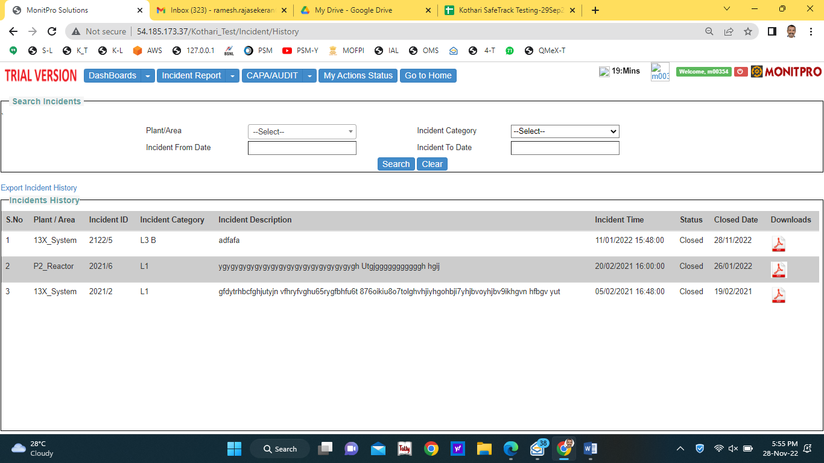

Add Filter: Incident Classification

Add Filter: Incident Classification

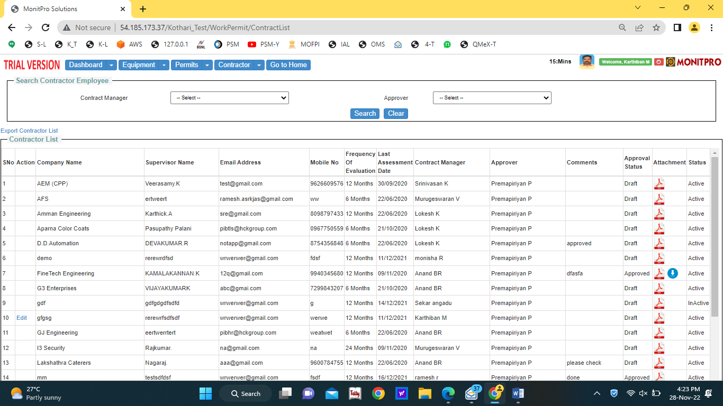

Search Contractor (Remove Employee)

Merge action column (edit icon) to the right Attachment (rename as Action)

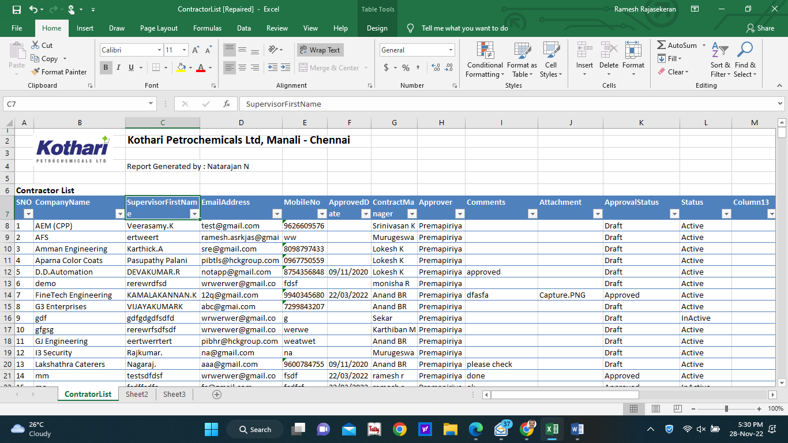

Logo to be reduced size to avoid overlapping with Report Generated by

Supervisor Name

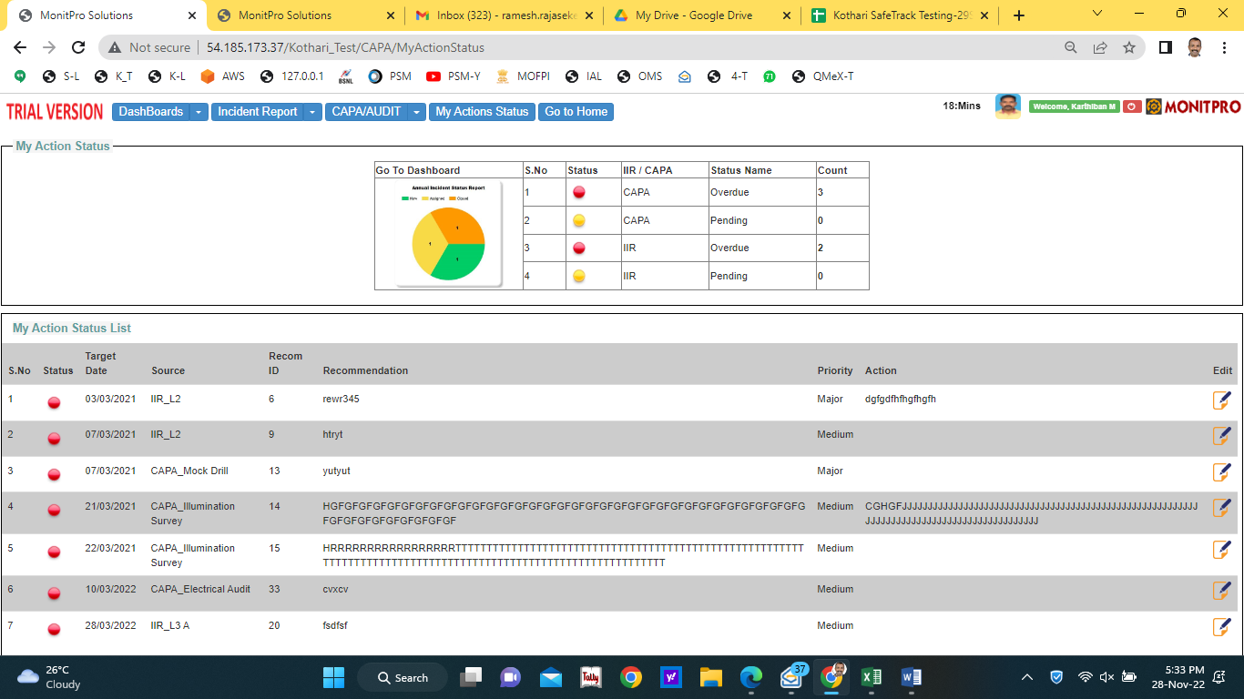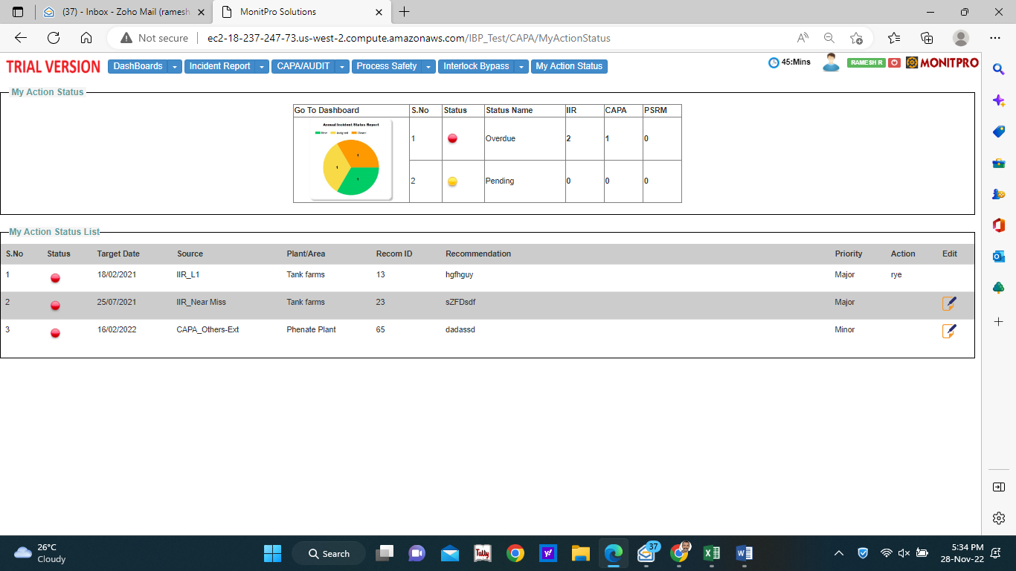

Can we design the table like IAL. See the Model below

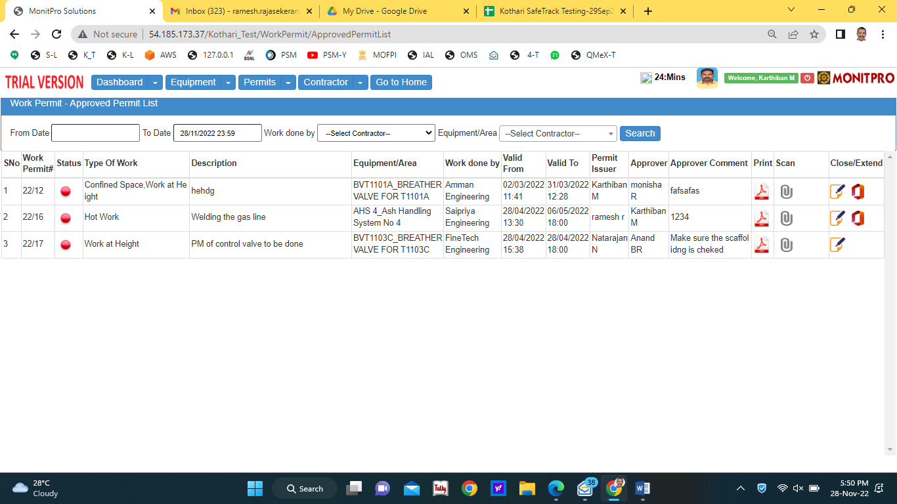

Clicking Permit list throws error

Can we merge Print/Scan – single column

